**13 aug 2020 hisory**

**network file system**

**History – server side**

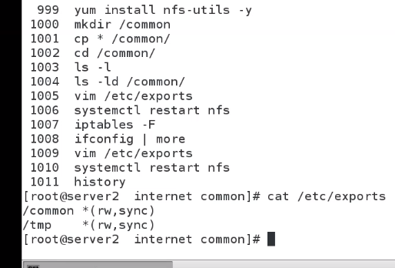

**Client side history**

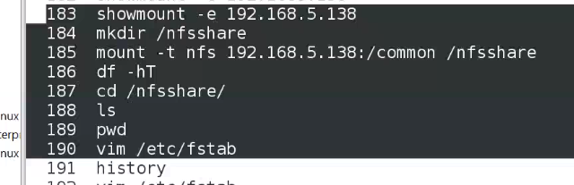

* **Lab …executing … doing in server { iptables –F to flush all connections }**

1. **Install nfs 2) mkdir common 3) cp all to common 4) cd to common 5) list 6) save persistently in /etc/exports the direc /common *(re,sync) & * ==> all servers**

**rw🡺 read, write, sync 🡺 synchronizing 7) restart network configuration file /etc/exports**

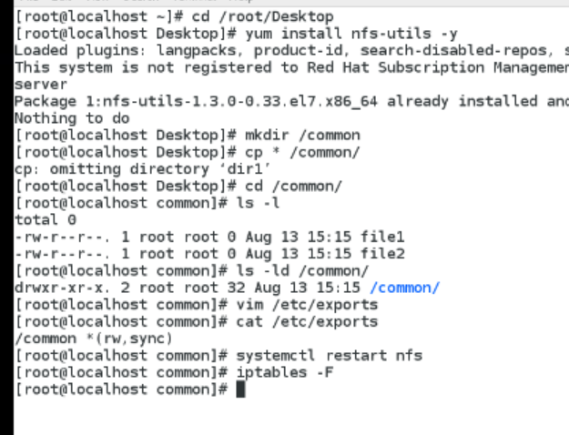

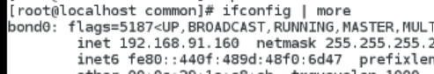

**Goto client**

**1)show mount –e ip address 🡺tolist mounted directories**

**2) mkdir /nfsshare**

**3) mounting nfs into /nfsshare**

**4) Check mounted ?? by using df –hT**

**5) Cd /nfsshare**

**6) all files are shared here**

**7) to do changes persistently do vim /etc/fstab**

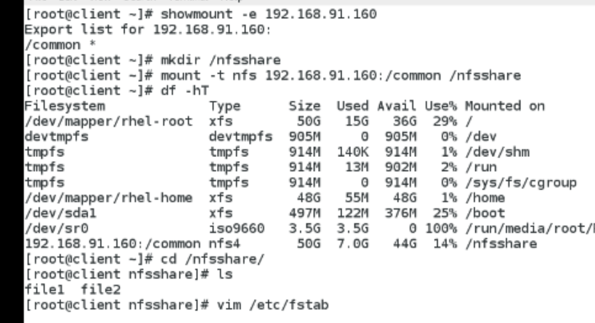

**Saving persistently in /etc/fstab**

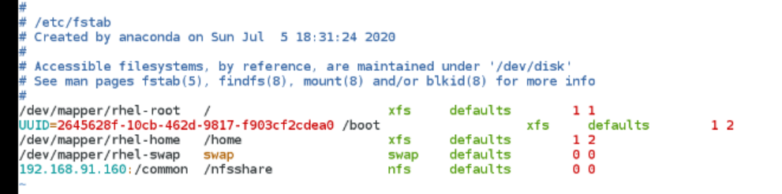

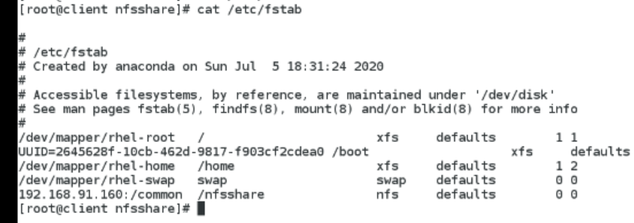

**Autofs – history**

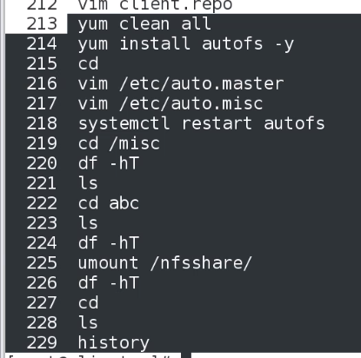

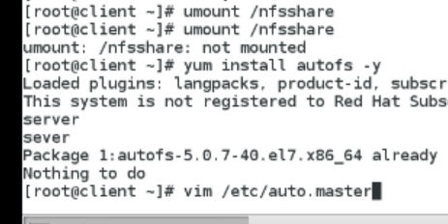

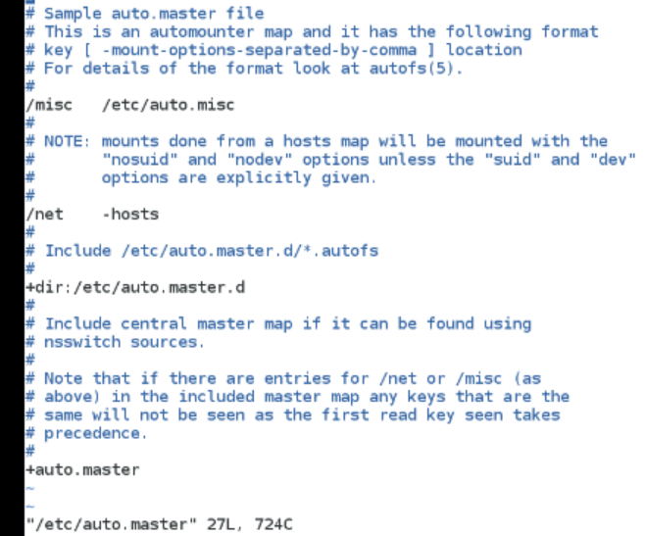



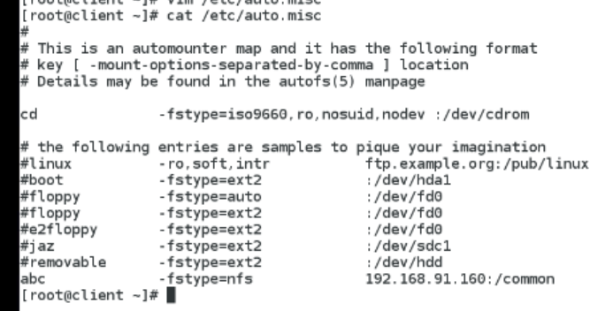

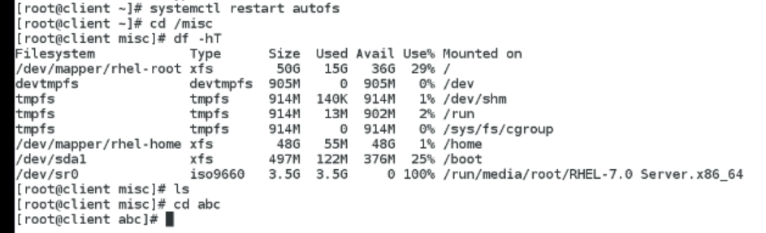

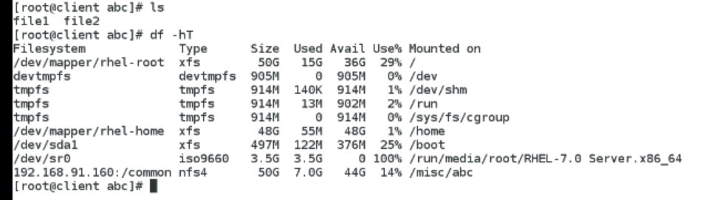

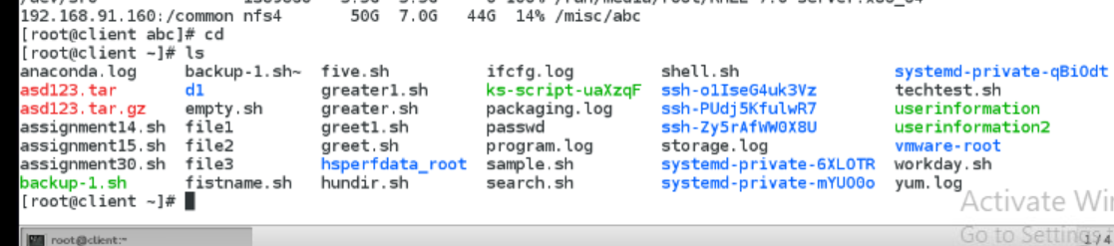

**Now it u switch to user1 and try to open file /etc/auto.misc it will open**

**After 6 minutes try to do & check the result**

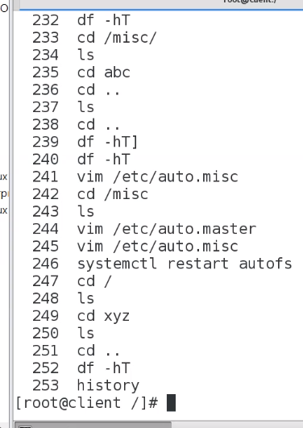

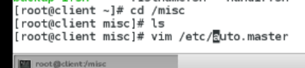

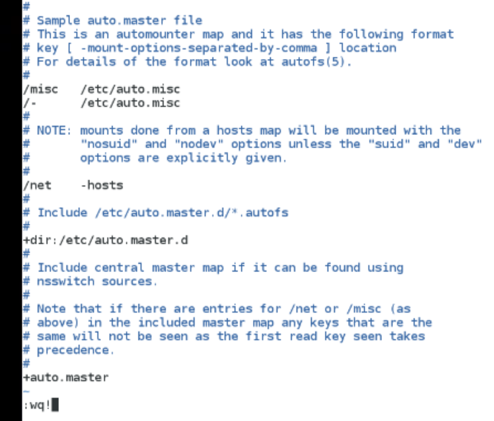



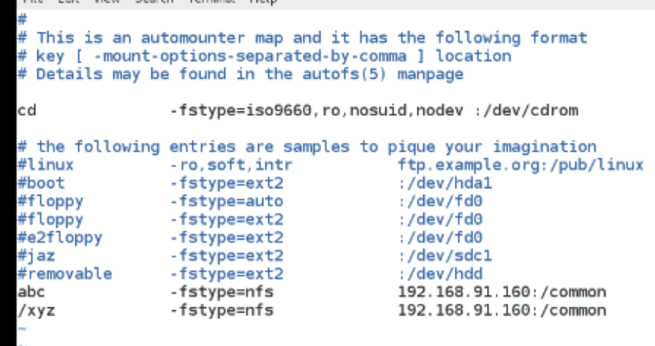

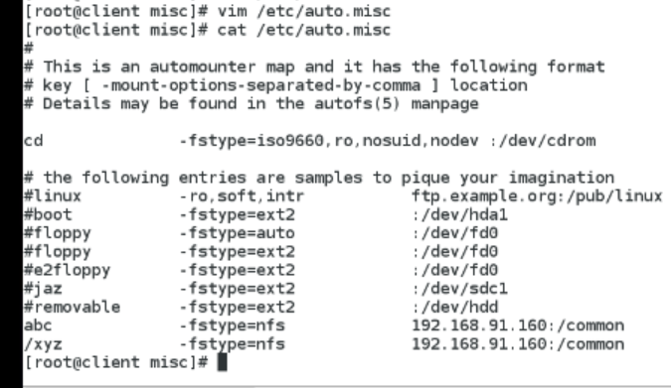

**Xyz present**

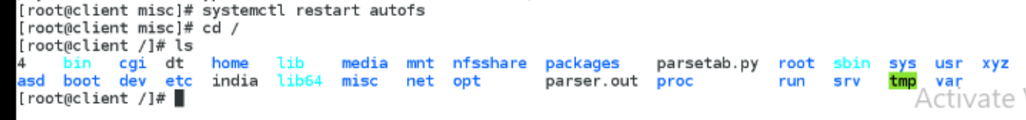

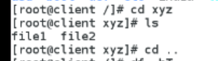

**If we give df –ht it should show xyz should be mounted**